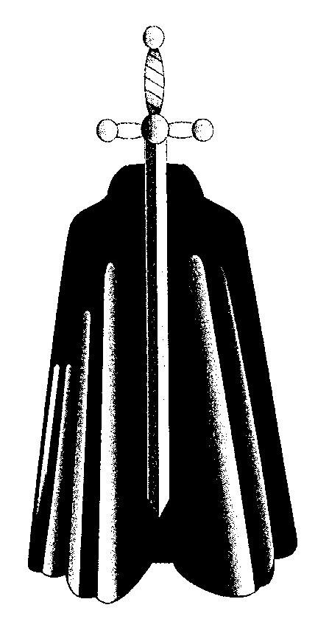
PAROCHIAL CHURCH COUNCIL OF ST MARTIN’S, LOW MARPLE

CONFLICT OF INTEREST POLICY

Preamble
Those responsible for administering a charity (the ‘charity trustees’) must act in the best interests of the charity. Amongst other things, that requires them to avoid anything that prevents decisions being taken by reference to other considerations. It also follows that charity trustees need to avoid putting themselves in a position in which their duty to act only in the best interests of the charity could conflict with any personal interest they may have.
This has implications in practice for both individual charity trustees and for the charity trustees collectively:
- individual charity trustees must identify and declare any conflict of interest on their part; and
- the charity trustees collectively must ensure that they have arrangements in place that enable conflicts of interest to be identified and dealt with effectively.
The early identification of conflicts of interest is therefore key to ensuring that both individual charity trustees and the charity trustees collectively do what is expected of them.
A conflict of interest policy is designed to ensure that the discussions and decisions of the charity trustees are not influenced by any other interests. Its purpose is to make sure that everything that may affect an individual charity trustee’s contribution to a decision is identified, dealt with appropriately and recorded. For general guidance to charities, you may find the Charity Commission’s guidance on this helpful.
A Parochial Church Council (PCC) is in no different a position in these respects from any other charity. Its charity trustees (ie all the individual members of the PCC) are under a legal obligation to act in its best interests. The church does not, however, operate in a vacuum: both it and its members form an integral part of the life of the community. This can give rise to conflicts of interest for individual members of the PCC where the best interests of the PCC may be at odds with those of other community organizations. And other conflicts of interest may arise from personal or family circumstances.
Where a conflict of interest is not identified and dealt with appropriately, it can result in decisions or actions that are not in the best interests of the PCC and/or which, in the case of interests of a personal kind, can confer an unauthorised benefit on one or more members of the PCC. [See also the Parish Resources Guidance Note: PCC members and private benefit]
Conflicts of interest can take many forms. Some will make it inappropriate for the individual to participate in a discussion or decision; others may simply need to be identified and declared, so allowing the individual to continue to contribute their experience and expertise to the matter at hand.

Policy
- This policy applies to all members of the PCC, the Standing Committee and any other committees or working parties set up by the PCC.
- A conflict of interest is any situation in which a member’s personal interests or loyalties could prevent, or could be seen to prevent, the member from making a decision only in the best interests of the PCC. Such a situation may arise either:
  - where there is a potential financial benefit to a member, whether directly or indirectly through a connected person (such as a close family member or business partner); or
  - where a member’s duty to the PCC may compete with a duty of loyalty he or she owes to another organization or person (eg by virtue of being a trustee or committee member of a body which has an interest in the matter).
- It is desirable that any conflicts of interest are declared to the Chair of the meeting as soon as the agenda is circulated. They must also be declared at the meeting when the relevant agenda item is reached.
- Subject to paragraph 6, where a conflict of interest arises in connection with a personal benefit, the member concerned must withdraw from the meeting and not take part in any discussions relating to it (including discussions for the purpose of obtaining any authority from the Charity Commission that would be required to authorize the benefit – see the Guidance Note: PCC members and private benefit).
- Subject to paragraph 6, where a conflict of loyalty arises, the PCC will consider what level of participation, if any, is acceptable on the part of the conflicted member, having regard to the duty to act in the best interests of the PCC. However, the normal expectation will be that the conflicted member should withdraw from the meeting during discussion of the item of business in question.
- A member need not withdraw from a meeting if his or her interest (whether financial or non-financial) is common to a class of persons and is neither (i) significant nor (ii) substantially greater than the interests of other members of that class.
- The existence of a conflict of interest must be recorded in the minutes, together with the decision as to how it should be dealt with.

This policy was adopted by the PCC on 21st June 2021.

https://www.gov.uk/guidance/manage-a-conflict-of-interest-in-your-charity
http://www.parishresources.org.uk/wp-content/uploads/remunerationguidance.pdf

